CIS-344
Professor: Yanilda Peralta Ramos
Project – 1

- Selection and Documentation
Ans. I have selected:
Remote Tech Support Service
This system is designed to manage operations of a company that provides remote technical assistance to customers via phone, chat, or remote desktop tools.
The system will handle:
- Customer registration and information
- Support ticket creation
- Technician assignment
- Service tracking
- Payment processing
- Issue resolution records
- Customer feedback
It has clear entities and relationships
It has real-world relevance
It contains enough complexity for ER modeling
It supports strong relational database design
It fits within the scope of a semester database requirement.
These reasons make my project appropriate for meeting the requirements.

- System Design Requirements
Information was gathered through:
- Informal interviews
- Workflow observations
- Scenario-based analysis
Each step of the requirement gathering process is documented below.
- Interview Process
To understand how a remote tech support service works, I talked to a few people who have used technical support before and one person who works in IT support. I asked them simple questions about how the process usually works.
Some of the questions I asked were:
- How do customers request technical support?
- What information do they need to provide?
- How are technicians assigned?
- What happens after the issue is solved?
- How do customers pay for the service?
From these discussions, I learned that customers usually provide their contact information and explain their issue in detail. I also found out that technicians are assigned based on their skills or specialization. After solving the issue, the service is recorded, and payment is usually made. Sometimes customers are asked to leave feedback about the service.
- Workflow Observation
After collecting information, I tried to understand the full process step by step. Based on what I learned, the typical workflow looks like this:
- A customer registers in the system.
- The customer creates a support ticket and explains the issue.
- The system assigns a technician.
- The technician connects remotely and fixes the problem.
- The resolution details are recorded.
- The customer makes payment.
- The customer may leave feedback.
By writing the workflow in steps, it became easier to identify what data needs to be stored in the database.
- Requirement Identification
Based on interviews and workflow analysis, I identified the main system requirements.
- Customer Requirements:
- Customers must register with their details like name, phone, email, address.
- Customers can create multiple support tickets.
- Customers can make payments.
- Customers can give feedback after service.

- Technician Requirements:
- Each technician has a unique ID.
- Each technician has a specialization.
- A technician can handle multiple tickets.
- Technician availability should be tracked.

- Ticket Requirements:
- Each ticket has a unique ID.
- Each ticket includes issue description, data, status, and priority.
- Each ticket belongs to one customer.
- Each ticket is assigned to one technician.

- Payment Requirements:
- Each payment has an ID.
- Payment includes date, amount, and method.
- Each payment is linked to a ticket.

- Feedback Requirements:
- Feedback includes ratings and comments.
- Feedback is linked to a specific ticket.
- Feedback is given by the customer.

- Assumptions Made:
While designing the system, I made some assumptions to keep the project simple and clear:
- A customer must register before creating a ticket.
- Each ticket is handled by only one technician.
- Each ticket has only one final payment.
- Feedback is optional.
- The system does not store video recordings of remote sessions.
These assumptions helped me limit the scope of the system and focus only on the main features needed for the database design.
- Entity- Relationship (ER) Diagrams.
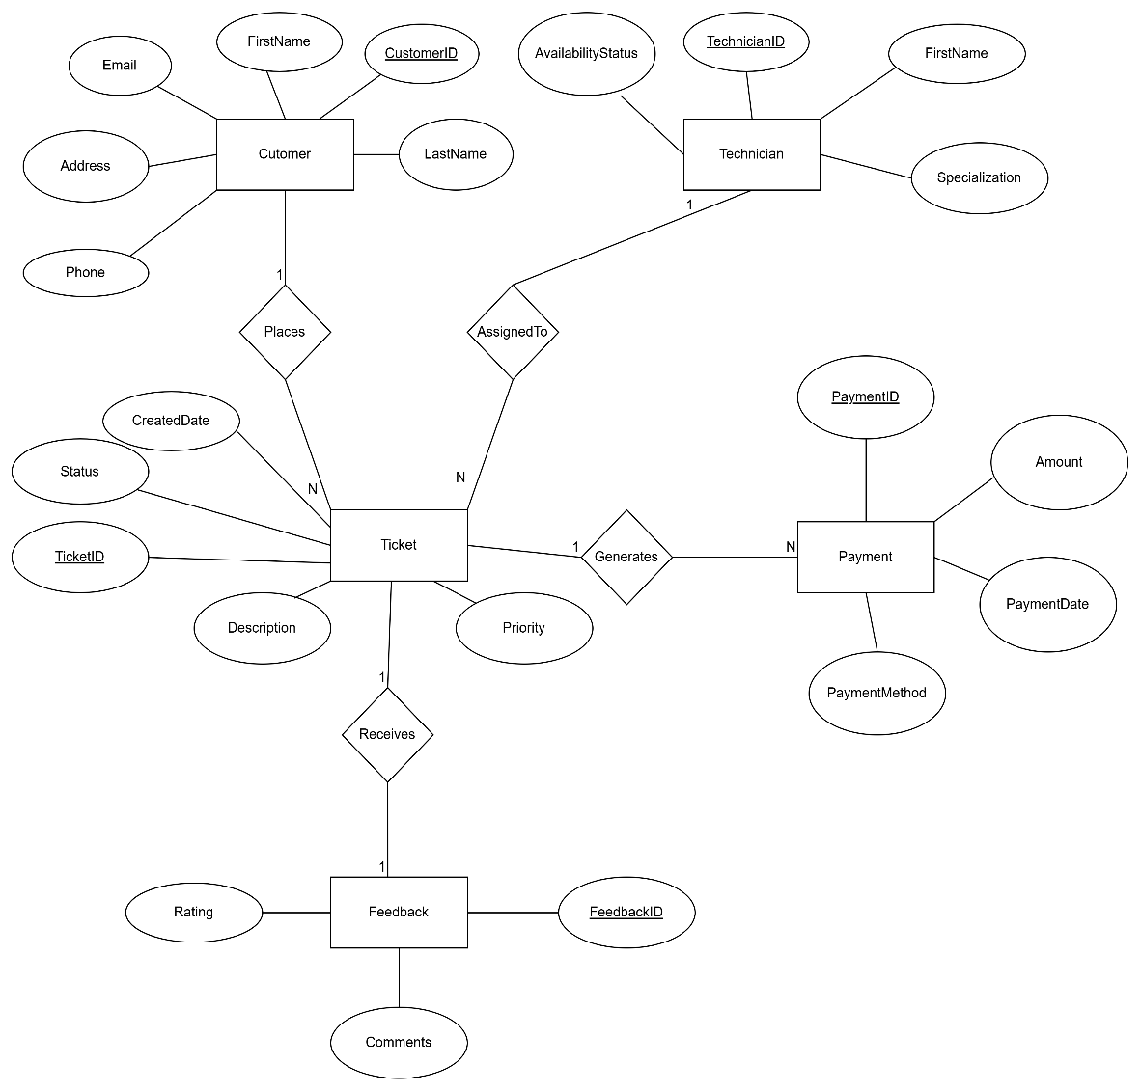

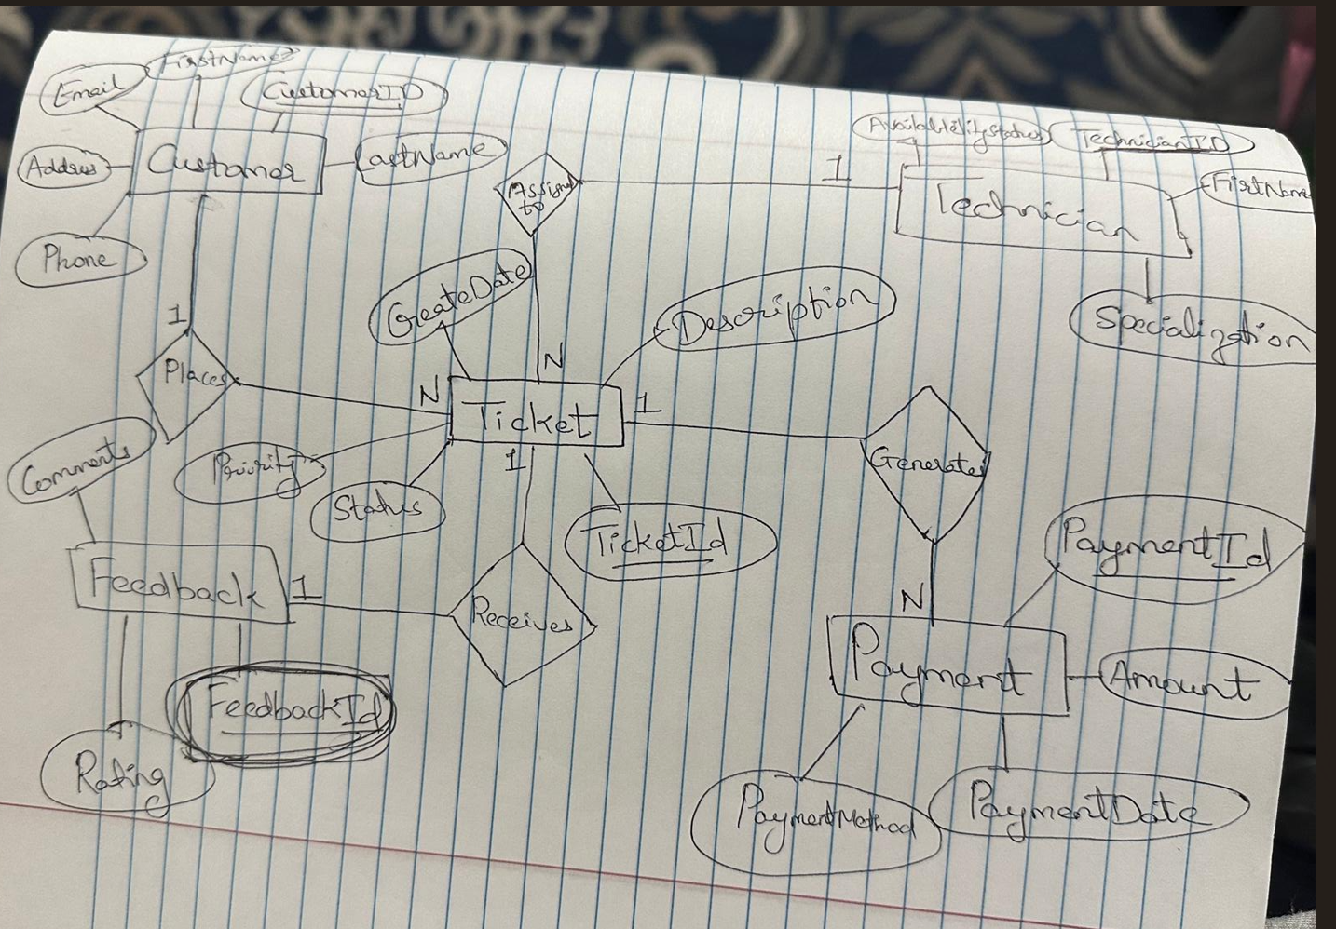

NOTE: Both diagrams are drawn by me using draw.io

- UML Style ER Diagram
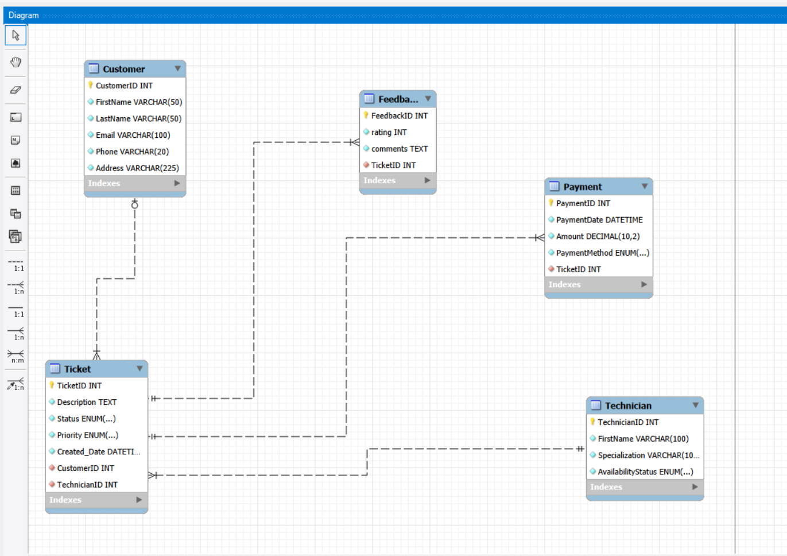

- Database Creation
It has been created and the files are attached in the folder.

- Final project report

- Project Scope
The main goal of this project was to design and implement a complete database system for a Remote Tech Support Service. The system was created to handle customer registration, support ticket creation, technician assignment, payment tracking, and customer feedback.
To complete this project, I followed the full database development process. This included gathering requirements, creating ER diagrams using both Chen and UML notation, building the database in MySQL Workbench, writing SQL scripts, and preparing proper documentation.
The project was designed to reflect a real-world service system. It helped demonstrate how relational databases can organize and manage customer information, service requests, and transactions efficiently and in a structured way.
- Challenges Faced
During this project, I faced several challenges that helped me learn more about database design and problem-solving.
1. Understanding Requirements
At the beginning, it was not easy to clearly define how a remote tech support service should operate. I had to carefully think about the workflow, make reasonable assumptions, and organize everything into structured data requirements.
2. Designing ER Diagrams
Creating both Chen-style and UML-style ER diagrams required attention to detail. I had to make sure that:
- Entities were correctly identified
- Attributes were placed in the right tables
- Relationships were properly defined
- Cardinalities were accurate
- Both diagrams represented the same structure
I had to revise the diagrams multiple times to make everything consistent.
3. SQL and MySQL Workbench Issues
While implementing the database, I experienced errors related to SQL_MODE, FOREIGN_KEY_CHECKS, and duplicate entries during forward engineering. These errors were confusing at first, but I solved them by cleaning the SQL script and ensuring the database was dropped before re-running the script.
4. Maintaining Consistency
One of the biggest challenges was making sure the Chen diagram, UML diagram, SQL schema, and Workbench model all matched perfectly. This required careful checking and corrections.

- Outcomes
Despite the challenges, I successfully completed all the required components of the project:
- A complete Chen-style ER diagram
- A UML-style ER diagram created in MySQL Workbench
- A fully functional database schema
- A clean SQL script for creating tables and inserting sample data
The final system correctly represents how a remote tech support service would manage customers, technicians, tickets, and payments. It shows a clear understanding of relational database concepts.

This project helped me improve my skills in:
- Requirement analysis
- Database modeling
- ER diagram creation
- Writing and debugging SQL
- Using MySQL Workbench
- Organizing technical documentation
It also taught me the importance of planning ahead, checking consistency, and reviewing work multiple times. Overall, this project gave me practical experience in designing a real-world database system.
Overall, this project meets all the required academic criteria and demonstrates a complete and well-structured database system. The diagrams, SQL scripts, and documentation work together to clearly explain the design and implementation of the Remote Tech Support Service database and strengthened my understanding of database design and gave me confidence in applying these skills in future projects.

